At Last: Sustainability in Action!
By: Whitney Ladwig
PLNT 4790: Karibu Kenya
Professors Dr. Dave Wilson and Dr. Urszula Norton

First, some introductions. Although you unavoidably came to know me “once upon a time in Kenya”, there are some things you may not know that are important to this paper. I am a senior in Earth System Science and Geography, Vice President of ACRES Student Farm, intern for the Campus Sustainability Council, and member of The Good Mule’s Earth Week council. That being said, I would also like to share that my least favorite word ever, is sustainability. I have spent much of my college career begging the campus community to recycle, compost, turn off the lights, grow wildflowers instead of Kentucky Bluegrass, and generally to conduct their everyday lives sustainably. Why don’t we? Why don’t most Americans? Convenience and short-term economics - what a luxury.
After my time in Kenya I’ve realized I don’t want to beg obese Americans to save energy by walking down the stairs instead of taking the elevator anymore, because Kenya revealed to me the great potential for sustainable development in developing countries. The organizations we encountered were not teaching sustainability to “save the Earth”; they were teaching “survival via the sustainable lifestyle.” Americans resist sustainable agriculture because they perceive it to be inconvenient and expensive; Kenyans are embracing sustainable agriculture because it puts food on the table, develops communities, and nourishes the land they depend on. Of course that is generalizing, but overall I felt that the organizations that we visited had an effective approach to teaching sustainability by embedding it within the contexts of individual and community economics and development. An analysis of how this was demonstrated at each site follows.
Vision Youth Correctional Agriculture Training Center
I found this organization to have a very inspiring mission – instead of putting “troubled” young men in jail, give them something to do (and teach them how to do it right). They implemented many projects familiar to us (composting, manure “tea”) as well as a few new ideas (permaculture with worms, rabbit and goat husbandry, goods production with farm products), but what I found most significant was the personal development aspect of the program. Theoretically, these boys would be able to return to their communities as respectable young men empowered with the knowledge to support themselves economically in an environmentally conscious way. In turn, they would also be capable of sharing these skills with their community, and in doing so, perhaps provide some semblance of economic stability. The Vision Youth Correctional Center demonstrated the means by which sustainability can be implemented within the framework of economic and social progress. How successful these efforts are, we don’t know – but at least the boys will leave with some understanding of self-sufficiency with a sustainable foundation.
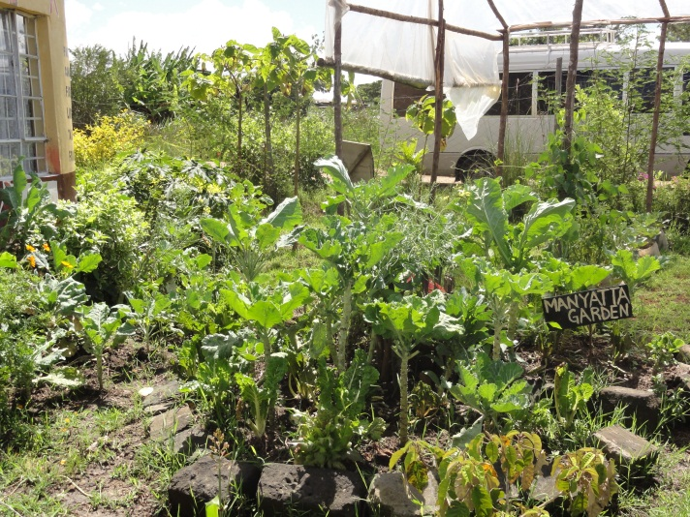
G-BIACK – Grow Bio-Intensive Agriculture Centre of Kenya
The most memorable part of G-BIACK for me was the huge sign they had posted which read “STOP GROWING CROPS AND START GROWING SOIL”. We were introduced to various techniques to restore and enrich soil with nutrients derived from compost, the most unique of which was the “Manyatta Garden” (see picture) in which compost is buried at the center of a circle shaped garden and plants are situated around it. The idea is that you water the garden at that center compost-rich point and the nutrients will dissipate into the surrounding soil and reach the plants’ roots. I’m curious about the effectiveness of this approach, but I imagine that the concentration of nutrients decreases with distance from that center point.
G-BIACK also served as an educational center for individuals to learn about bio-intensive agriculture, small business management (tailoring, bead work) and nutrition – all skills that will ideally enable an individual or small family to provide for themselves. Once again, environmental sustainability is implanted within a program designed at helping people help themselves. They are essentially demonstrating to their students that if you want a productive garden to feed your family, you must first nourish the soil. On a continent where soil erosion is a major problem, this is a very important part of agricultural education. While that broader issue is meaningless to people trying to simply feed themselves, making it applicable to their personal survival enables people to address it. At G-BIACK, we saw that agricultural sustainability can be beneficial to both the short-term lifespan of the individual and the long-term health of the land.
COSDEP – Community Sustainable Development Empowerment Program
This organization was focused on facilitating the implementation of sustainable agriculture on pre-existing farms by educating local small-scale farmers. They reported that they were founded as a Community Based Organization whose purpose was to train the local village of Kiambu on organic farming and personal nutrition. The need for that type of education was great enough in the many surrounding poor communities, however, that they eventually expanded to NGO status in order to branch out to those more rural areas.
Fundamentally, they are training local farmers how to manage a farm capable of sustaining the health and economic needs of their families and villages while using ecologically sound methods. Their approach is aimed at addressing nutritional needs, but also provides some financial stability to those involved on the farms. Those farmers are then encouraged to exchange their knowledge with other farmers to empower more communities to sustain themselves. The rural villages we saw were particularly impoverished and COSDEP served to set the framework for jobs, food, and income. Once again, sustainability means nothing to a starving family, but when it is entrenched in a method for survival everyone (including the land) benefits.
Flamingo Flower Farm
The operations at Flamingo Farms were extremely high-tech in contrast to other farming operations we saw, but they proved that high-tech does not necessarily mean sustainable. They derive all of their water from Lake Naivasha - along with a number of other large scale flower farms - and so the Lake is suffering rapid depletion. They reported being part of a consortium of Lake Naivasha dependent farms working towards implementing more long-term sustainable standards to ensure there is water enough for all in the future. Whether or not “all” includes the poor villages along Lake Naivasha’s shores, they did not report.
Their technology was therefore mostly focused on water conservation, including hydroponic growing systems which deliver any extra water and fertilizer to soil crops, and a wetland-oriented filtration system to manage runoff. In the end, however, they are still using fertilizers and pesticides on their crops, pumping energy into environmental control of their huge greenhouses, and managing a flower farm in a desert that ships products all the way to Europe. It appeared to me that they were implementing “sustainable” techniques in order to save them money (by reducing waste), not out of concern for their impact on the local or global environment. Sustainability can be interpreted in many ways: economic, environmental, social – and the methods by which some organizations approach sustainability do not always address all three. However, companies know that many customers do not understand this and will still freely advertise how “sustainable” they are. It’s all relative, correct?
Ketepa Tea Factory and Finlays Tea Estates
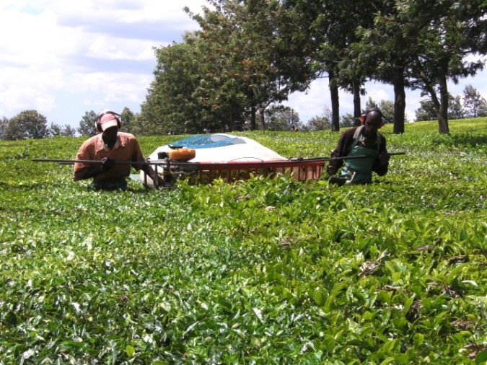
These companies were very impressed with themselves. Finlay’s emphasized their Fair Trade and ISO certification, and were eager to show off their newly implemented mechanized tea leaf trimmer. After touring both the fields and the factory, I think we were all really beginning to doubt what levels of standards are necessary for those aforementioned certifications.
Here again we saw the difference between economic and social sustainability. While mechanization will save the company money on labor costs, it will also likely mean a downsizing of the labor force, as they reported that the work of 25 hand-picking harvesters can be reduced to 2 harvesters with one of those machines. They reported management over approximately 14,000 employees, with 95% housed on the Finlay property. Thus, most likely any layoffs will also result in homelessness.
Then there’s the question of environmental sustainability. They noted that the tea plants responded with better regeneration after hand-picking, and that as a result they have to use more intensive fertilizers to achieve the same production levels they had originally attained. Yummy, everyone likes a little fertilizer in their tea. Most of that fertilizer, however, appeared to be draining into the watershed. They reported that they use “lots” of fertilizer to get the results they need, but that approximately 25% of that fertilizer is washed away into a 70 meter riparian buffer they constructed to catch this waste, and it was pretty volatile looking when we passed over it. In addition, the factory itself was powered off of Eucalyptus wood-burning fuel which probably leaves a pretty heavy carbon footprint.
It was interesting to see that in Kenya they are still somewhat in the beginning of their industrialization process; if Fair Trade and ISO raised their standards, they could help developing countries circumnavigate the destructive consequences and instead direct them towards implementing more socially, environmentally and economically sustainable practices.
MHAC - Manor House Agricultural Center
The Manor House encompassed many of the approaches and projects we had seen before – it was an educational center where students could take courses on bio-intensive agriculture aimed at enabling small-scale poor farmers to optimize crop output with sustainable practices. Exploding with sustainability in every sense! Instead of reiterating that point, I will share one fun thing we learned instead - double digging.
While this activity was somewhat labor intensive, the effort seemed well worth the result. Double digging addressed the fact that the soil structure there ends in a “dead pan” only a few feet below the surface, resulting in a highly stressed environment for roots competing for very limited resources. In the U.S., we resolve this issue by plowing. In Kenya, they carry out a process called double-digging which essentially loosens and aerates the soil while redistributing nutrients so that roots can more easily spread out reducing stress on the plants. We use this method at ACRES Student Farm and have always had successful results.
Metisi Urban Garden
This project was managed by an alumnus of the MHAC and sat in the middle of a pretty impoverished city. It served as a community garden where people could volunteer their help and earn produce in return. Many of the details here were lost to me as it was difficult to understand because of the language barrier, but I’m going to interpolate that this garden serves as a center of community development since it was providing an opportunity to learn about responsible agriculture techniques while earning food. Also memorable was the fact that since it was the dry season they had very little water, preventing them from growing many crops. This demonstrated the larger issue of climate-related drought affecting the smaller scale issue of everyday life. Sure you can grow bio-intensive, but if you don’t have water you don’t have a very productive farm.
Kilili Self Help Group
I really enjoyed the emphasis here on growing plants that were indigenous to Kenya as a way to preserve Kenyan culture. Since people are always debating the definition of sustainability anyway, I think it’s fair to invent “cultural sustainability” or the active preservation of culture over the long term by embedding it in the present. It seemed that we saw the same crops in every garden and it was refreshing to see native plants, such as amaranth and nightshade. Growing indigenous crops also has value in the fact that these plants evolved to grow in Kenya’s climatic conditions, and therefore will likely not require intensive fertilizers and watering to ensure survival. Environmental sustainability once again is partnered within a form of social sustainability, which is sometimes more easily promoted.
Macedonia Self Help Group
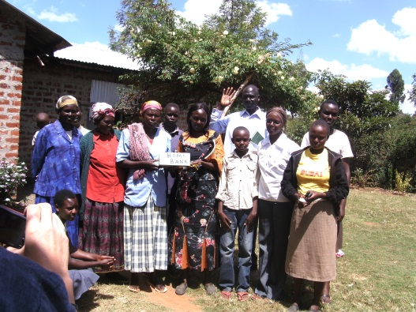
The sustainable practices we saw here were mostly a repeat of earlier sites; however they had a very strong community-oriented framework. Serving as a demonstration to other villages, they established a community bank that created a center of financial stability to support all who contributed to it. This was especially important for female empowerment since most women are not allowed to man age money and are therefore dependent on men to support them and their family, which is not always very reliable (straight from their mouths). However, when the successes of the group can be shared by all, women can apply for micro-loans to invest in economic enterprises which may pay back even more. Thus, the profits gained by their environmentally sustainable farming can then be used to invest in other economically sustainable activities, and this is all socially sustainable since it is a globally recognized fact that the education and equality of women is central to the progress of any people.
Agroforestry Project
Established as a Swedish investment, this project focused primarily on training farmers to integrate trees into their croplands as a way to both conserve soil and diversify their crops to include trees with economic value. In addition, they instructed farmers on financial management which included setting up “village savings” to alleviate HIV/AIDS stress. They also provided education on climate change and the consequential importance of sustainable farming. The Agroforestry Project appealed to farmers economically because they promote growing trees with an economic value but they embedded environmental, social and economic values in their training as well. The trees serve to decrease soil erosion, the cultural value of indigenous trees is preserved and (likely most important to them) they make the farmers money. That money is then invested in the community, and that knowledge can be shared for further community development and stability.
In a developing country, I came to understand that it is equally important to educate people on how to act environmentally responsible as it is to integrate community building efforts and individual development opportunities. Sustainability is only effective in a community where there are first economic, then social and environmental profits. Many of the nameless farmers these programs are directed at are simply trying to survive and so economic benefits must be made obvious to trigger motivation to adapt to new techniques and ideas. It is interesting that in a country where culture plays such a significant role in everyday life that “new” agricultural techniques are so readily accepted, whereas in the “developed” U.S.A. we are hung up on our good-old American way of doing things (plow it, sow it, drown it in fertilizer, park the tractor). Perhaps if Kenyan farmers did have widespread access to fertilizers this would not be so, however it seems that poverty has in some way enabled sustainable agriculture movements to capture the attention of a large group of farmers. Will the foundation of these “sustainable” principles set the stage for a better tomorrow in Kenya? Time will tell.

